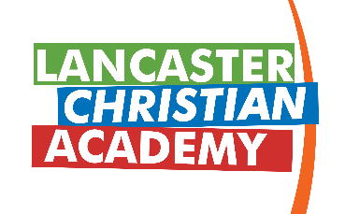

Orientation Notes

Non–Traditional School Dates: The Tennessee Association of Non-Public Academic Schools allows their schools to create unique experiences that count toward the attendance records and total number of school days within a school year. You will notice that LCA will take four-day weekends at times and also will always be closed on Good Friday when public schools are still in session. We reserve the right to plan differently than the traditional public-school calendar. Staff and students are expected to report on the noted days. We want to give ample time for families to plan. The following dates are counted as school days for LCA students as a part of our program:

7th-12th Grade (Overnight Retreat) Thursday, September 1st
K5 Readiness-12th Grade (L.A.M.P.) Monday, May 22nd
K5-12th Grade (L.A.M.P.) Tuesday, May 23rd

Backpacks: Due to the close proximity of lockers and classrooms (and to avoid congestion in the hallways) students in grades 7th-12th will NOT be allowed to carry backpacks on campus. Exceptions will be made for students on individual education plans that solicit a need for a backpack.

Locker Lock: All students in grades 3rd-12th will be issued a school locker at LCA. Students are required to purchase a lock from the school so that school officials have access. Locks are $30. The same lock CAN be used each year. Locks may be purchased at orientation today. The fee for a lock is covered for 3rd-12th grade families who have chosen the all-inclusive tuition package.

Uniform Shirts: Students in grades Kindergarten Readiness through 12th grade must purchase a LCA uniform polo shirt for our dress code. You may order at orientation today or at central office. The fee for two uniform polos is covered for K-12th grade families who have chosen the all-inclusive tuition package.

Parking Passes: Student drivers must purchase a parking permit if they drive a vehicle to school. This purchase also provides the student with an off-campus lunch pass. Parking permits are $75 and may be purchased at the orientation today. The fee for the parking pass is covered for families who have chosen the all-inclusive tuition package.

Kindergarten Readiness Bags: Each of our Kindergarten Readiness students will receive an LCA bag today at orientation to be used on the hook outside their classroom in place of a backpack or other bag. This is for items that you bring to school daily or items that you leave at school for the week. Please bring your child’s bag to school beginning on Monday to start getting in the habit of using it. K5R Students should be bringing only the following items with them to school: a complete change of clothes (shirt, pants/shorts, socks, and underwear), a sheet, a blanket, a pillow and one soft, quiet sleep buddy. All items need to be labeled with your child’s name and able to fit inside their blue bag.

